QUADRILATERALS
A quadrilateral is a plane shape that has four (4) sides. Quadrilaterals include:
- Rectangles
- Squares
- Parallelograms
- Rhombuses
- Trapeziums
- Kites
Properties of Quadrilaterals
- Rectangles
- The opposite sides are equal in length
- The opposite sides are parallel
- All angles are equal. Each angle is equal to 90º (i.e. right angles)
- The two diagonals are equal in length
- They have 2 (two) lines of symmetry
- The diagonals bisect each other
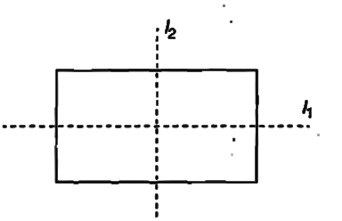

- Squares
- Each interior angle is equal t 90º
- All sides are equal in length
- Opposite sides are parallel
- The diagonals intersect at 90º
- The diagonals bisect corner angles so that each angle is 45º
- They have four lines of symmetry
- The diagonals bisect each other
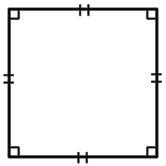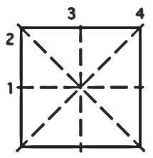
- Parallelograms
- Both pairs of opposite sides are parallel
- Opposite sides are equal in length
- Opposite angles are equal in size
- No line of symmetry
- The diagonals bisect each other
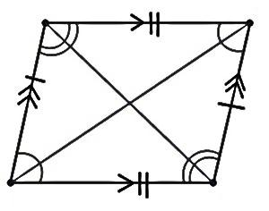
- Rhombuses
- All sides are equal
- Opposite angles are equal in size
- Opposite sides are parallel
- Each diagonal bisect the corner angles
- Diagonals intersect at 90º
- The diagonals bisect each other
- They have two lines of symmetry
- Trapeziums
A trapezium is a quadrilateral that has one pair of opposite sides parallel. There are two types of trapezium:
- Isosceles trapezium
- Non-isosceles trapezium

Isosceles trapezium
- One pair of opposite sides is parallel
- The parallel sides are not equal in length
- They have two pairs of equal angles
- They have equal diagonals
- They have one line of symmetry
- The non-parallel opposite sides are equal in length.

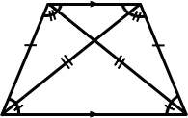

Non-isosceles trapezium
- One pair of opposite sides is parallel
- No line of symmetry
- Kites
- The adjacent pairs of sides are equal in length
- One pair of opposite angle is equal in size
- Diagonals intersect at right angle (90º)
- One diagonal bisects the other diagonal
- They have one line of symmetry
