Week 3: SS1
Subject: Computer/ Data Processing
Topic: Tools for information Processing
Sub-topic: Labeling the Excel environment.
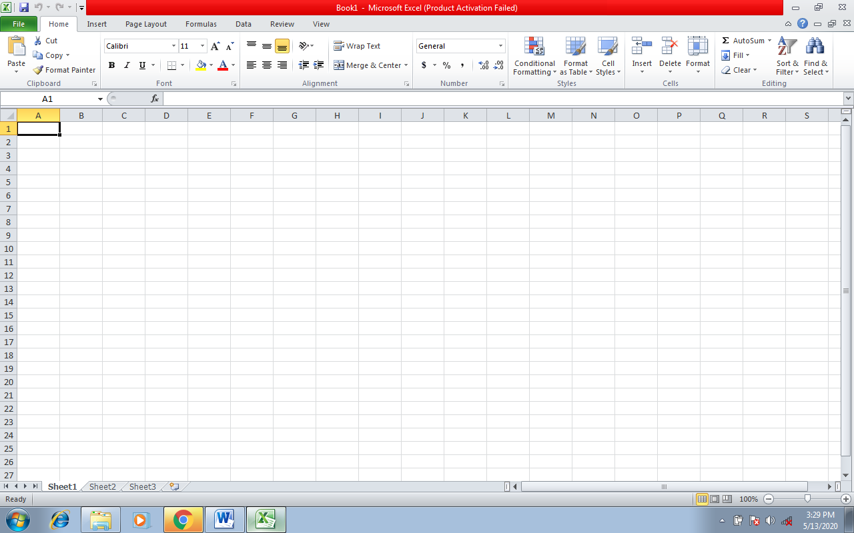
Scroll Box
Scroll Bar
Scroll Box
Scroll Bar
Status Bar
Cell Reference
Column
Row
Formular Bar
Close
Maximize
Minimize
Menu Bar
Title Bar
Standard tool Bar
Formatting tool Bar
Task Bar
Task Bar

