CULTURAL AND CREATIVE ART FOR JSS2
TOPIC: TRADITIONAL. NIGERIA ART (ESIE AND TSOEDE)
ESIE ART: Esie is a town in Kwara state, largely populated by Igbomina people. This art was first discovered by a hunter named Baragon in 1775. The sculptures were found arranged in circular position with one in the middle, more like a King holding meeting with his subjects. The place was converted to a shrine where worship takes place.
This art remained silent, until Mr.H.G.Ramshaw, a school inspector with the Missionary Society in 1933 brought it to public notice. Government then took over the ownership and transformed them into Star attraction of the Esie museum which was built in 1945.
The origin of this art is not traceable. It has been a consistent mystery to historians and archeologists. Legend has it that these statues were once human beings who became ossified when they rebelled against the town's leadership. This myth is further is further rooted in the fact that no two sculptures look the same.
Many soapstone figures numbering from 800 to 1000 were discovered.
Characteristics
*They have almost real figures seated or kneeling while holding on to agricultural or musical instruments.
*They wore beads around the neck and wrist.
*They have distinct facial marks which consists three horizontal lines between the eyes and ear, and vertical lines on their chin.
*Some of them are decorated with elaborate hair styles.
Material used: soap stone(soft rock)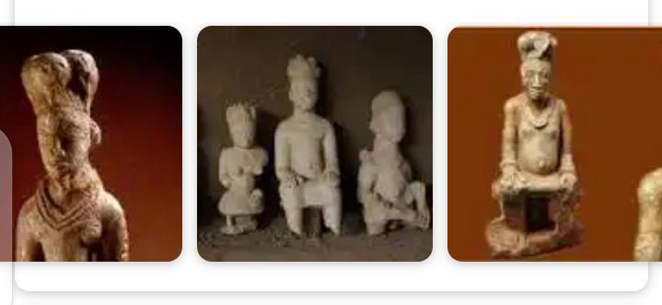
TSOEDE BRONZES (NUPE):
TSOEDE is from Igala, born of Nupe woman. He was the unifier of the Nupe people and the first Etsu (king) of Nupe kingdom. He died in 1591, in one of his military expeditions.
He was taken as a slave to the palace of Igala King who took him as a son and heir apparent. When the king died, his half-brothers conspired against him, which made him to leave Igala and relocate to his people.
He traveled in a celebrated bronze canoe and on his way dropped some bronze works to the neighboring communities like Tada,Jebba and Giragi. He introduced the art of bronze casting to Nupe community.
Through his military expeditions, he unified the 12 federated villages that speak Nupe in one as Nupe kingdom. He developed his kingdom, especially in the areas of arts and culture of which credit is still given to him till date as Tsoede bronzes. Some bronze artifacts from his kingdom are on display at the National Museum, Lagos.
CHARACTERISTICS
*They have naturalistic figures.
*They have large figures of man and animals. Some of their works were the largest cast bronze figures found in Sub-Sahara Africa from antiquity.
Function: It is for ritual purpose.
Material used: bronze.
