CULTURAL AND CREATIVE ART FOR JSS2
TOPIC: NIGERIA TRADITIONAL ART (IFE AND BENIN)
IFE ART (Osun state) - Ife is the ancestral home of the Yoruba's in Nigeria. Their art existed between 1100AD and 1400AD. This city have a tradition which resembled Nok in their beading.
CHARACTERISTICS
*Their art is naturalistic.
*They made realistic figures.
*They have beaded necklaces, anklets and bracelets.
*The face of their figures are decorated with scarification (tribal mark).
*They practice cire perdue process (lost wax technique of casting).
Material used: Clay and bronze
Function: it is used to immortalize some personalities.
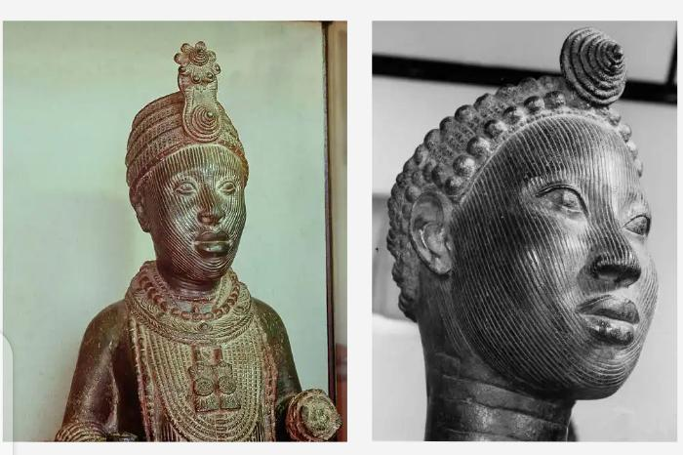

BENIN ART (Edo state)
Benin art was believed to have started around 14th century AD. They learnt the art of bronze casting from Ife caster,who was invited to teach Bini craftsmen the art of making memorial heads in bronze for ancestral alters. These heads have caps and high collars representing coral beads worn by the Oba of Benin during ceremonies.
Bini craftsmen on their own style used animal motifs that had no religious symbol which made their art to be called COURT ART. They made plaques depicting warriors and hunters which they hung in Obas chamber. They use the shape of leopard to make vessels for Obas washing of hands.
CHARACTERISTICS
*They made sculptures in Ivory and bronze.
*They made standing sculptures.
Material used: Ivory and bronze
Functions: Their art is used to glorify the Oba.
*They are used to patronize Oba's Court.
Assignment:
Draw one Ife figure and one Benin figure. You can choose anyone from your textbook.

