Mathematics SSS1
Similar Triagles
Below are two similar triangles: ABC and DEF
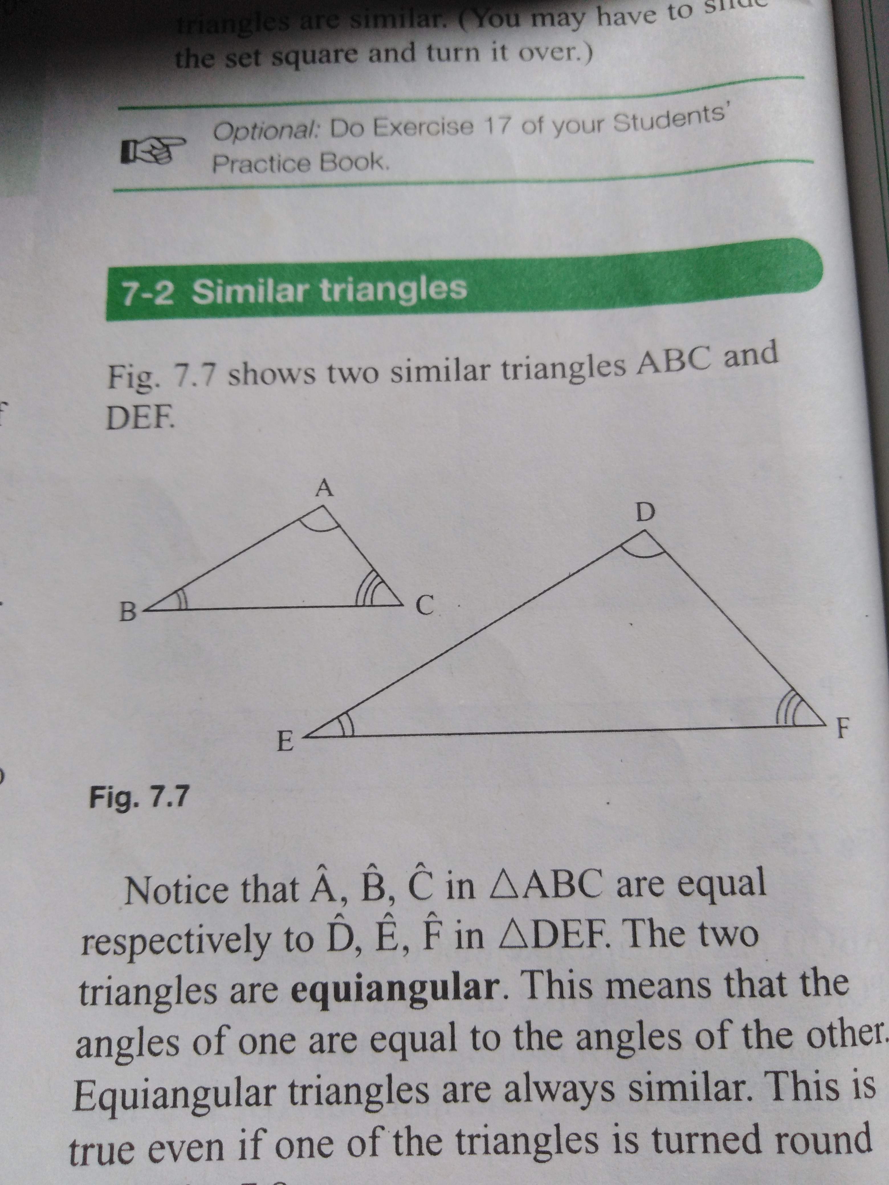
Notice that that angle A, B, and C in triangle ABC are equal respectively to angles D, E andF in triangle DEF. This means that the angles of one are equal to the angle of the other. Equiangular triangles are always similar.
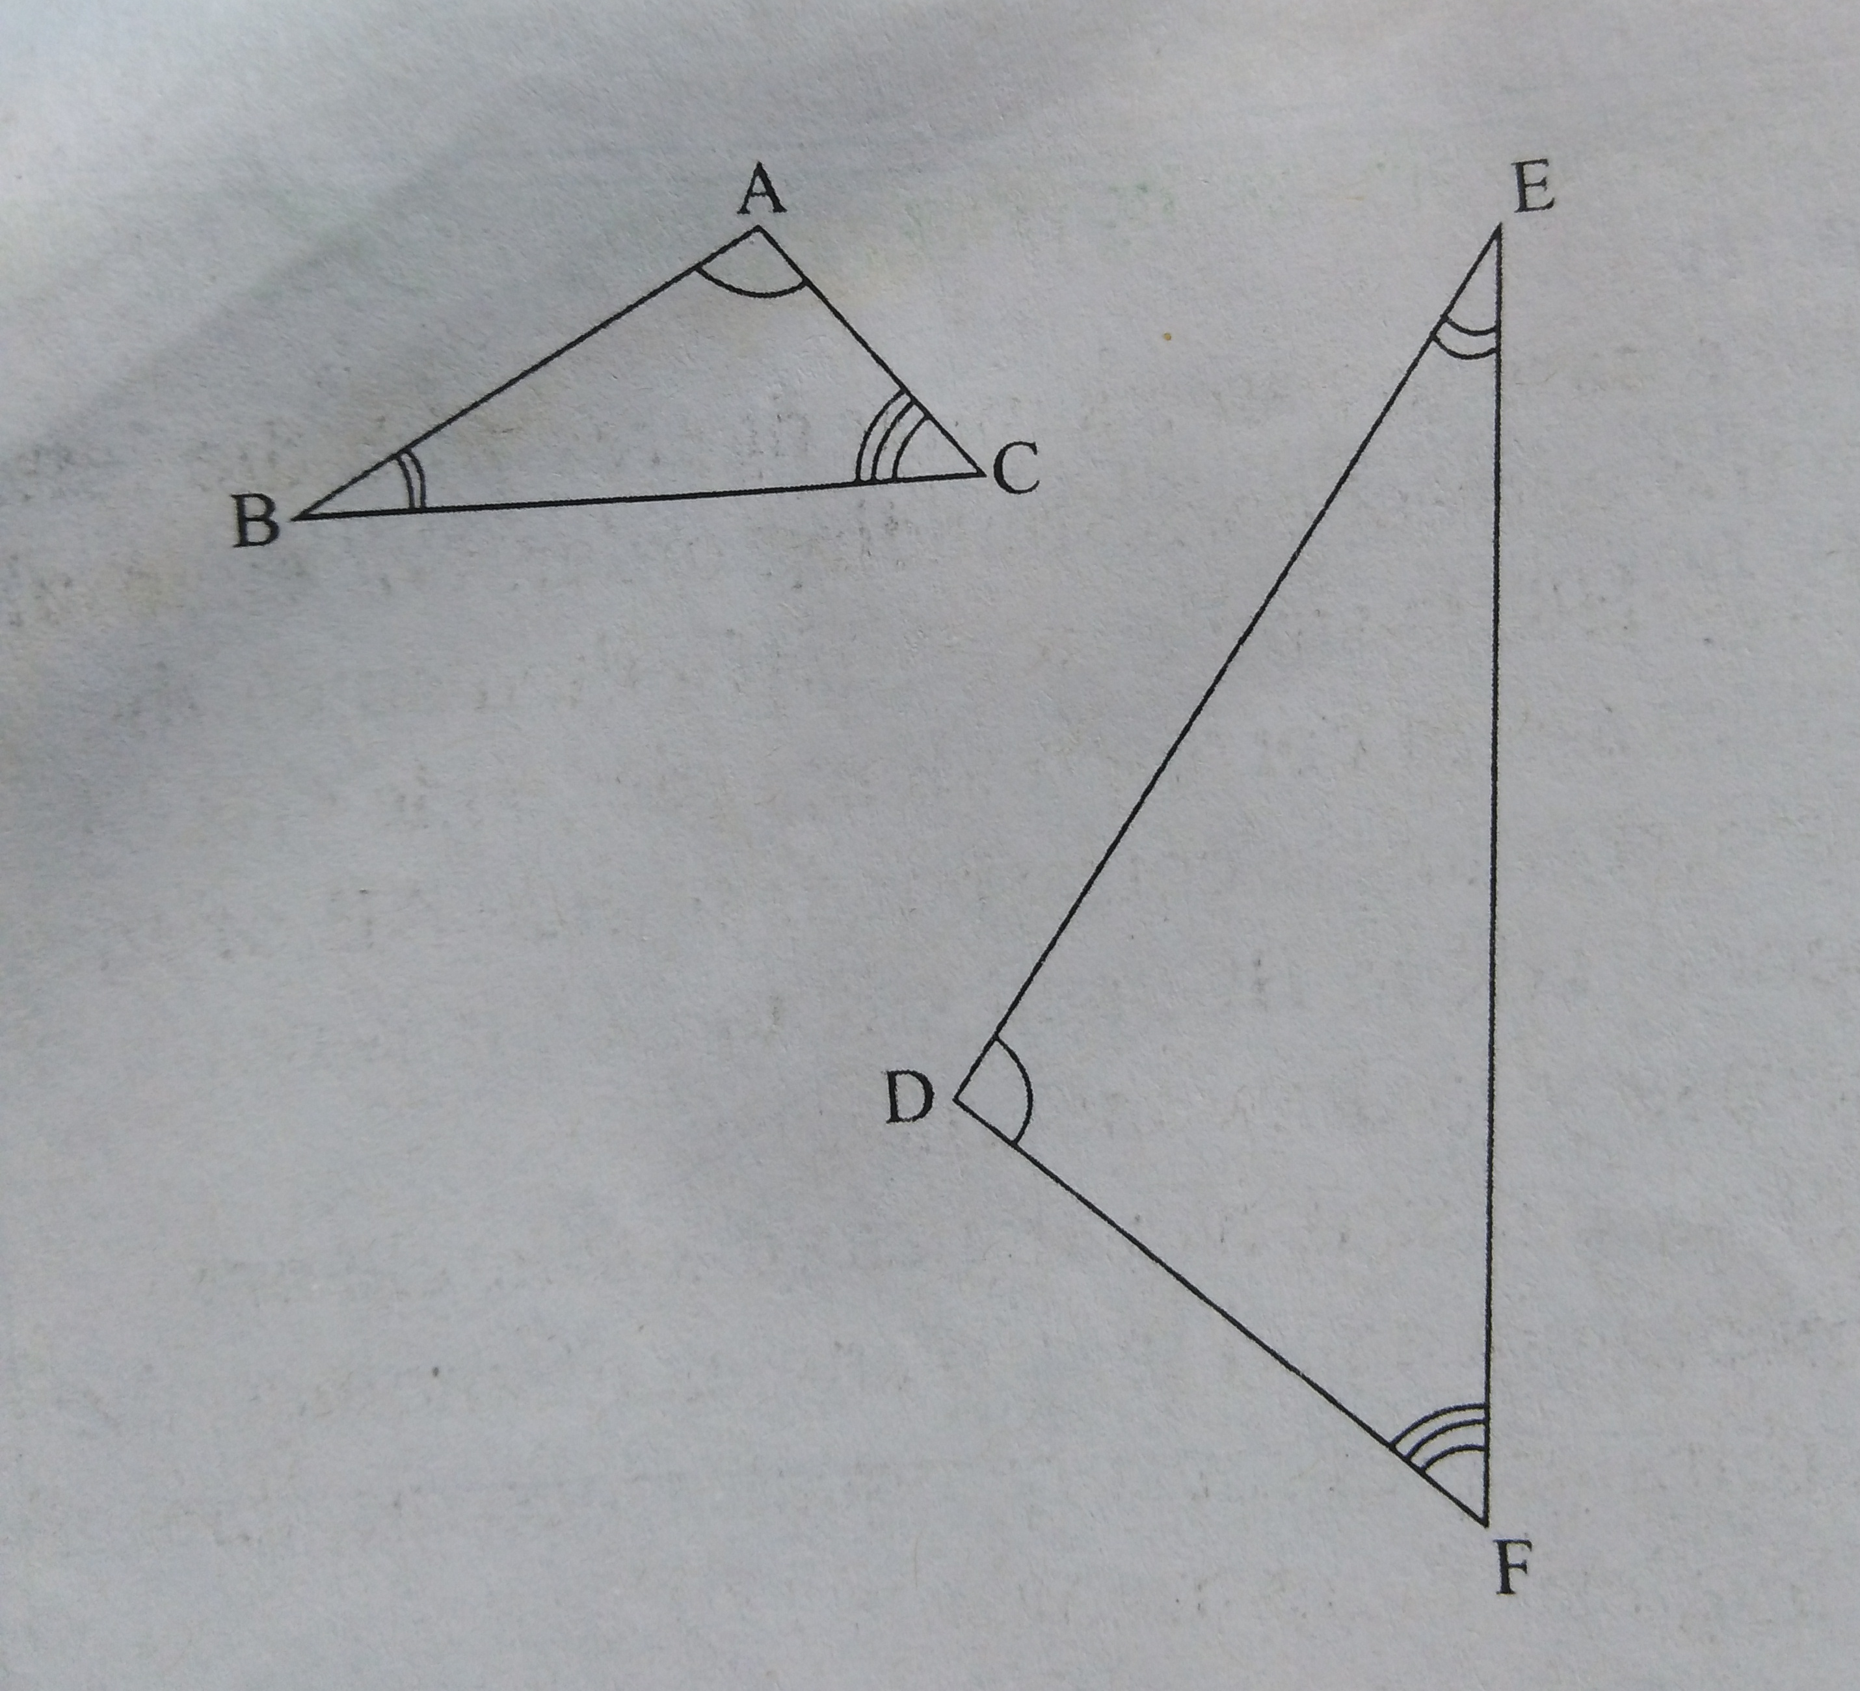
No matter the direction of the triangles, as long as there are three corresponding angles of the triangles that are equal. The triangles are similar.
In both cases angle A =D and angle B =E. C = F. This means side AB corresponds to side DE. Also, angle C = F. This means that side AC corresponds to side DF. Similarly, side BC corresponds to side EF.
Notice that corresponding sides are opposite equal angles. Below is the illustration of the equal angle of the similar triangles.
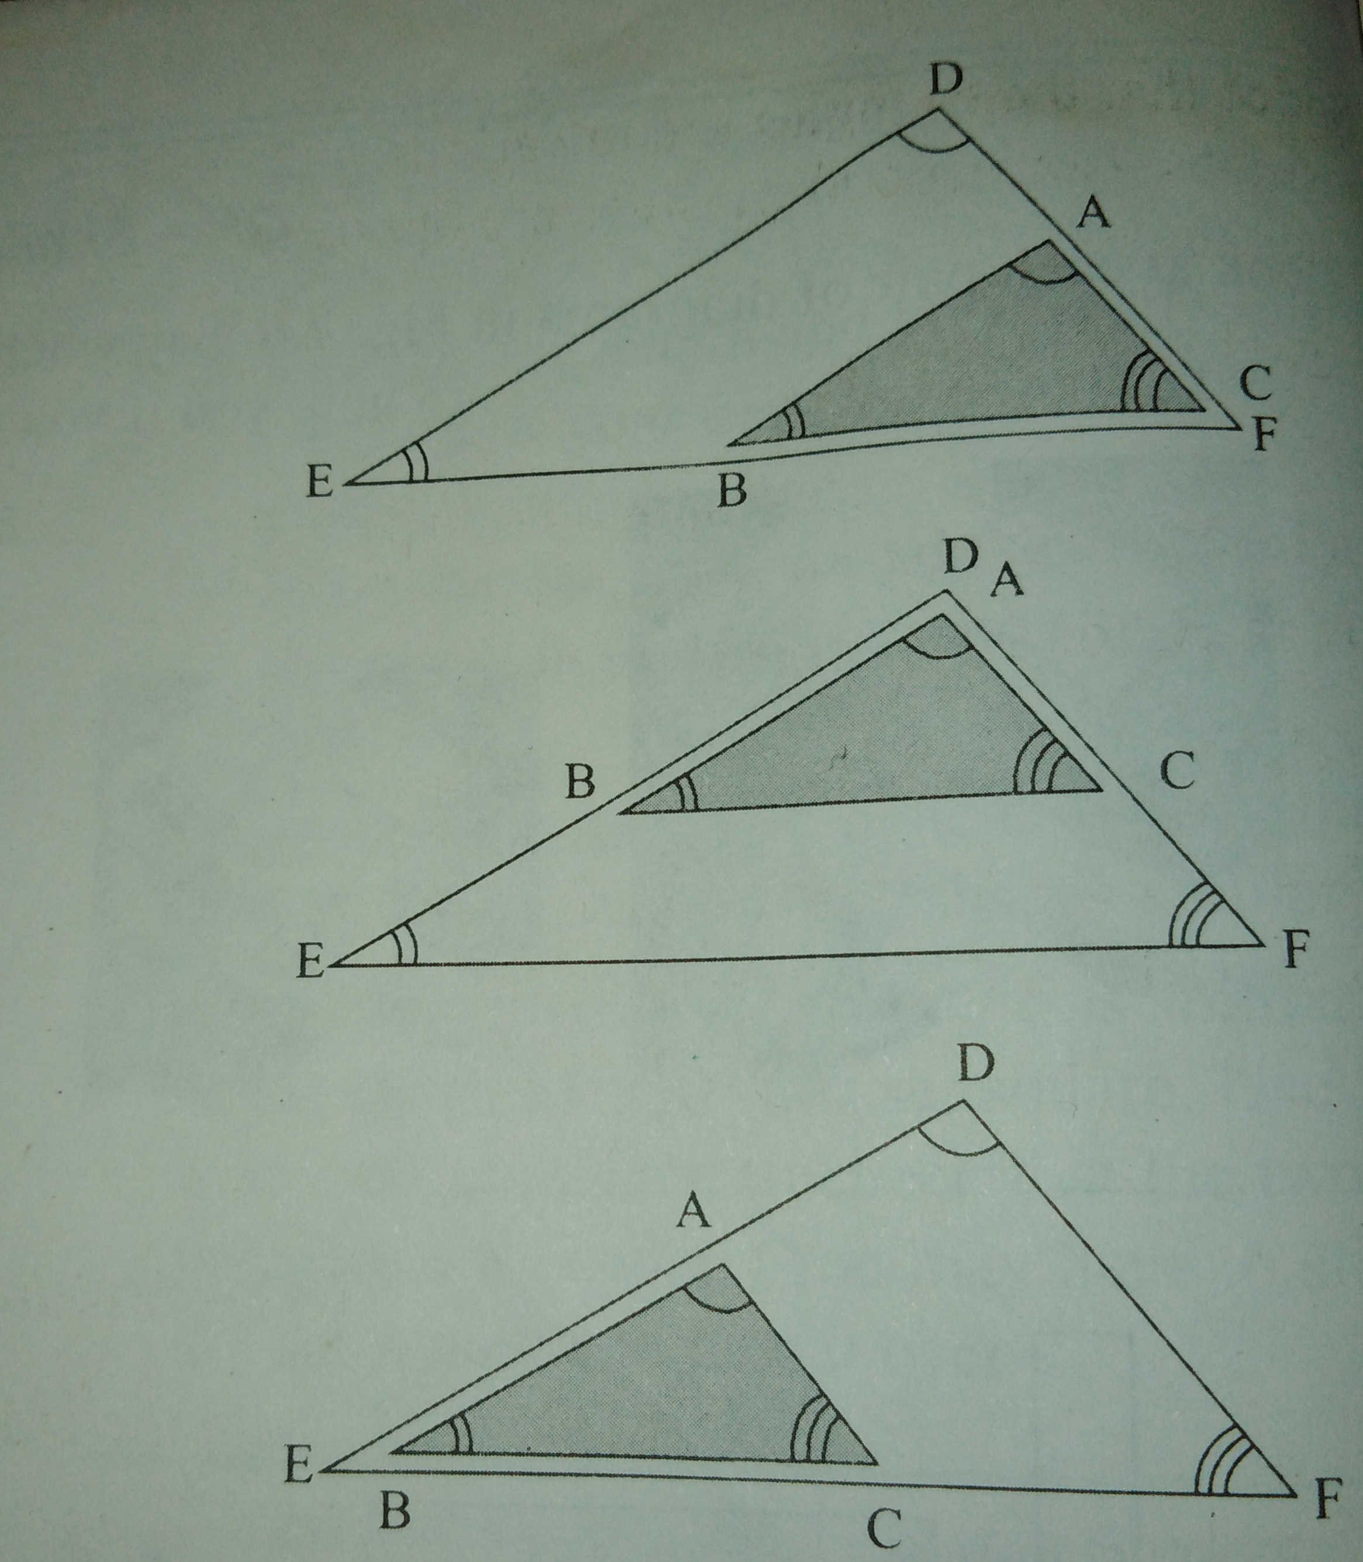
Naming Similar Triagles
Great cares are to be taken when naming similar triangles. The way similar triangles are named shows the equal angles and the corresponding sides. The above similar triangles can be named thus:
Triangle ABC corresponds to triangle DEF. From the naming you can deduced that the angles A = D, angle B = D, and angle C = F. Also, it can be deduced that side AB corresponds to side DE, side AC corresponds to side DF, and side BC corresponds to side EF.
Note that even as triangle ABC is similar to triangle DEF. You can't say that it is similar to DFE or EDF though they are the same triangles. You must name them in accordance to the equal angles. Also note that even though side EF is the same as side FE. Side BC corresponds to side EF, but it doesn't correspond to side FE. Rather Side BC corresponds to side EF, while side CB corresponds to side FE.
TRIAL QUESTION.
Name the following similar triangles stating the equal angles and the corresponding sides.
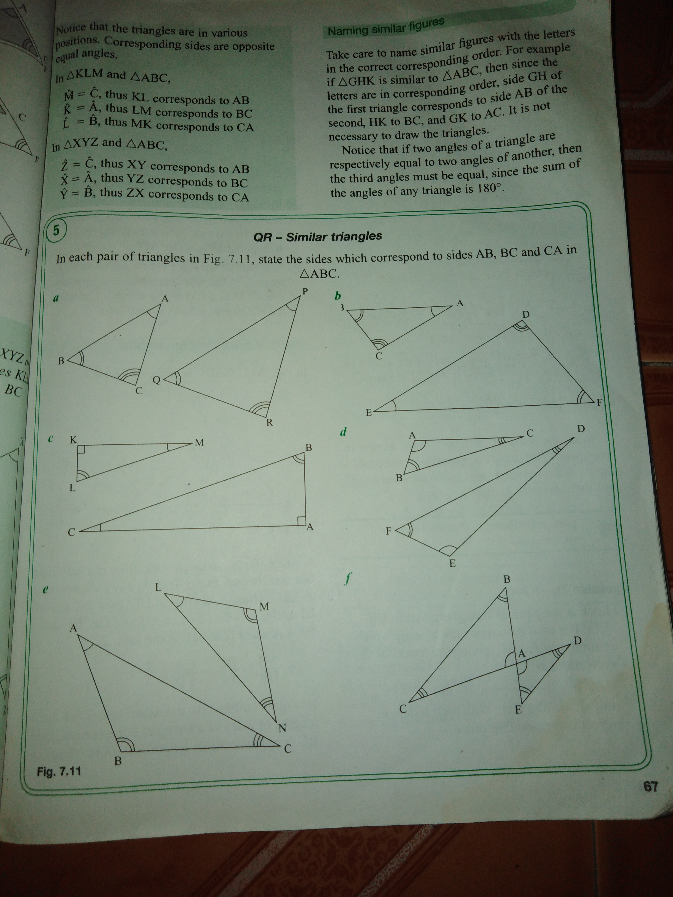
Submit the trial work to your class WhatsApp group. On Friday 5th May 2020 between 8:00pm to 8:40pm we shall have a general class discussion on your solutions. Ensure you participate.
Example1
Calculate the missing angles in the triangles below. Hence show that the triangles are similar, naming them with their letters in correct corresponding order.
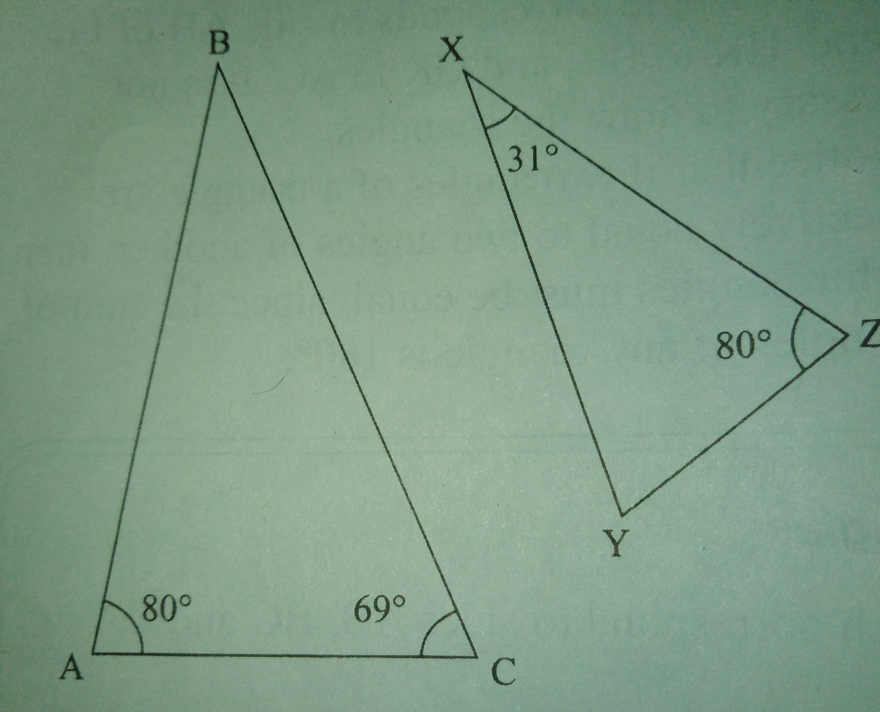
Solution
In triangle ABC angles A + B + C = 180º (sum of the interior angles of a triangle is 180º ).
80º +B + 69º = 180º
B =180º — 80º — 69º
B = 31.
In the two triangles, X = B = 31, Z = B=80º . Therefore Y = C = 69º. Therefore triangle ABC is similar to triangle ZXY.
Ratios of corresponding sides
Below are two similar triangles
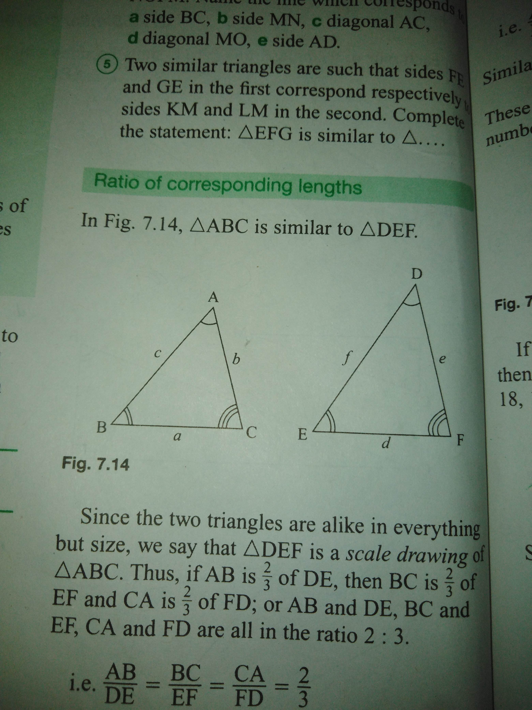
Triangle ABC is similar to triangle DEF. Therefore sides AB and DE correspond, sides BC and EF correspond, side CA and FD correspond. Therefore
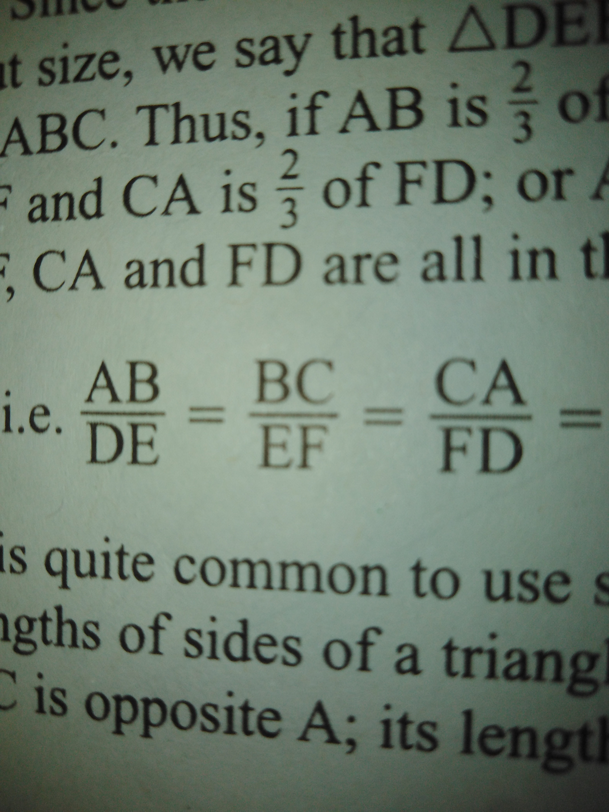
The corresponding sides of similar triangles are at equal ratio. Similarly
This can be more understandable using numbers
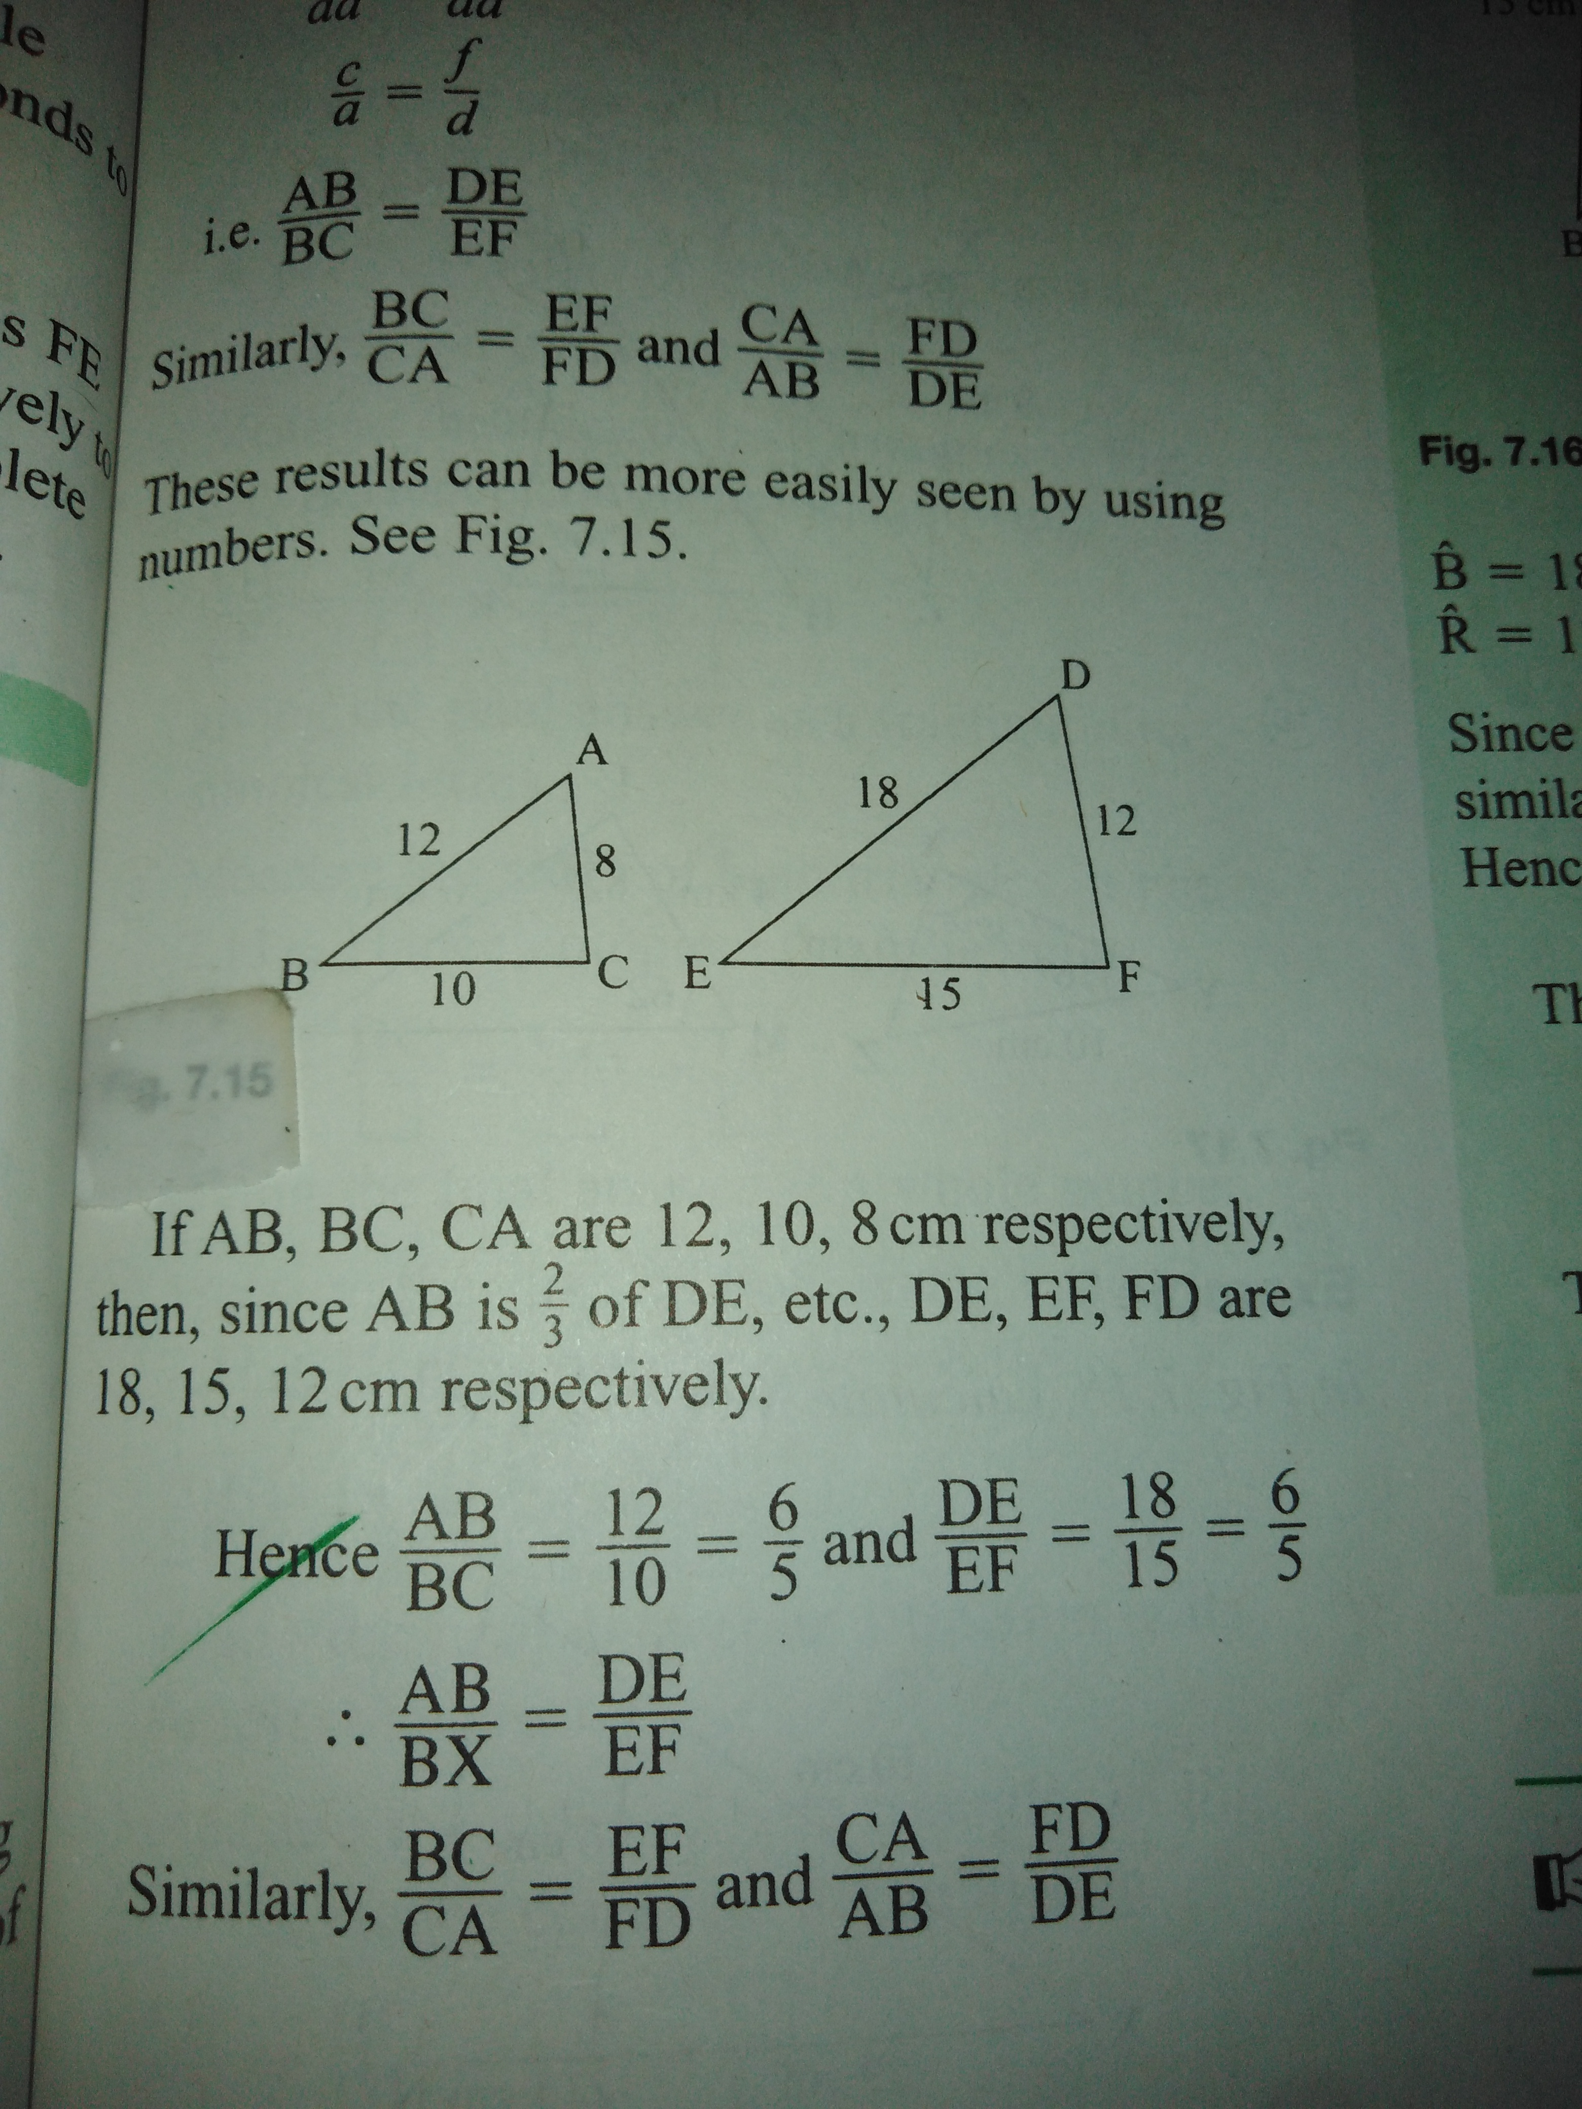
Example2
In the below diagram, show that the two triangles are similar. Name the triangles given the letters in corresponding order. Hence calculate BC and RQ.
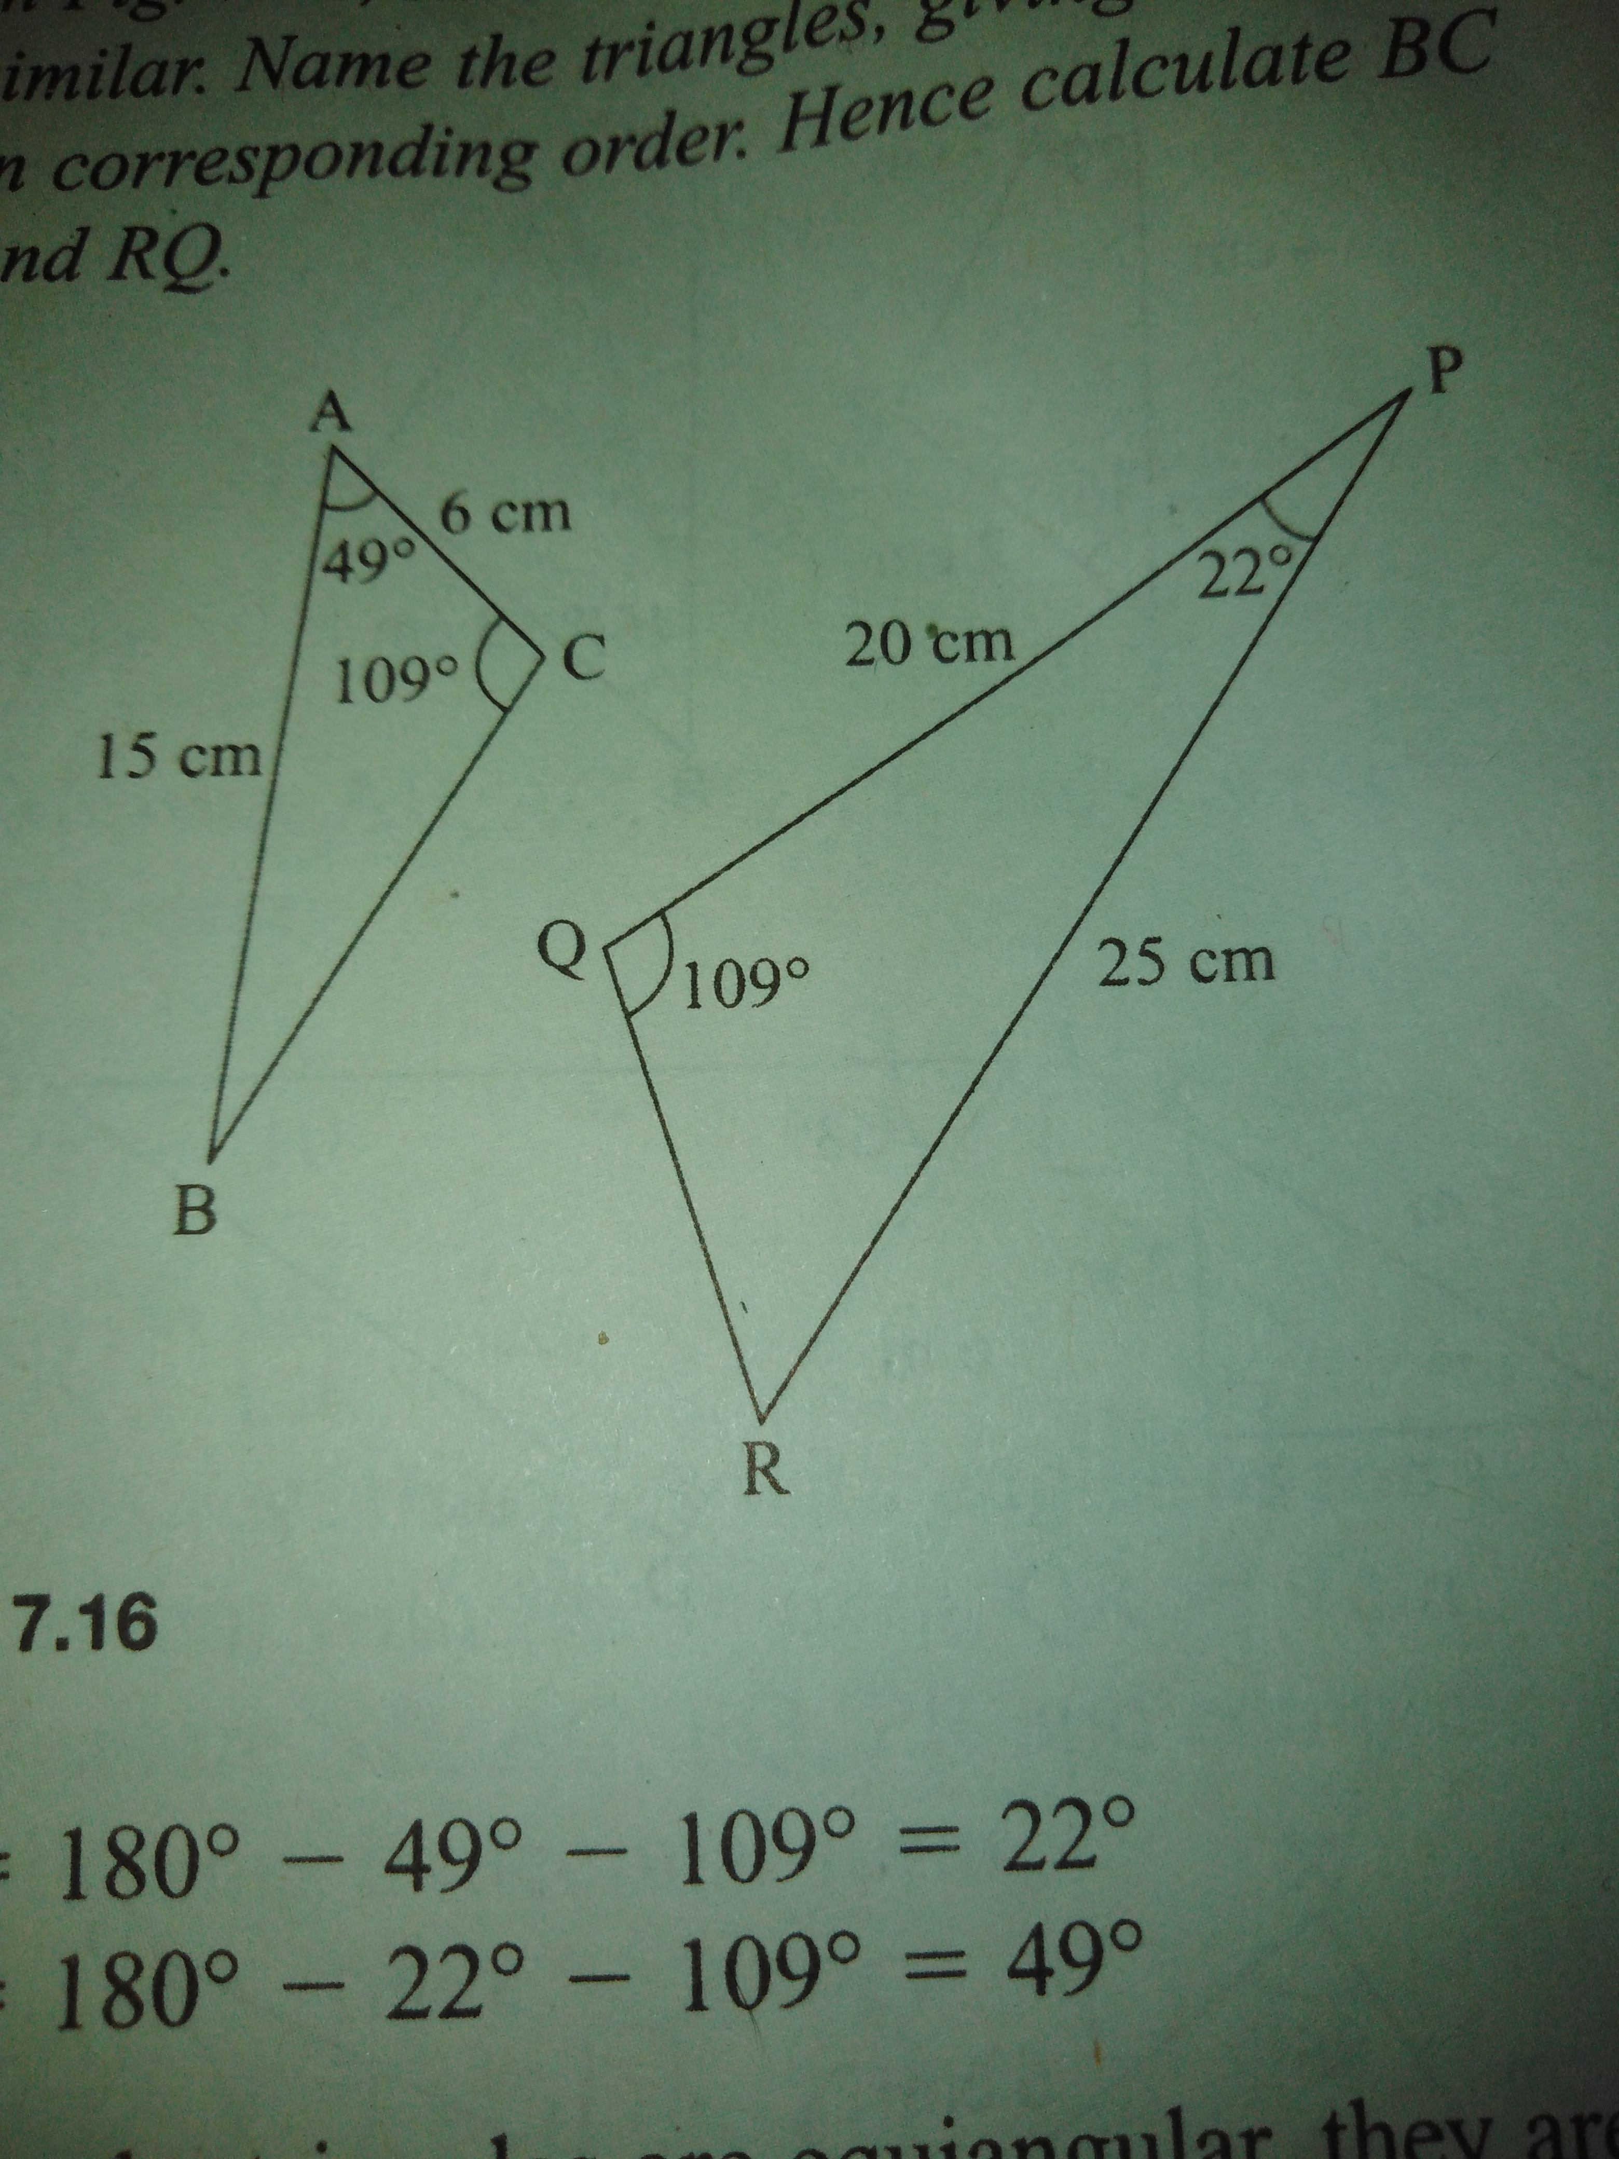
Solution
In triangle ABC, A + B + C = 180º
(sum of the interior angles of a triangle is 180º ).
49º + B + 109º= 180º
B = 180º — 109º — 49º
B = 22º
In the two triangles Q = C = 109º, B = P = 22º, therefore R = A = 49º. This means that triangle ABC corresponds to triangle RPQ.
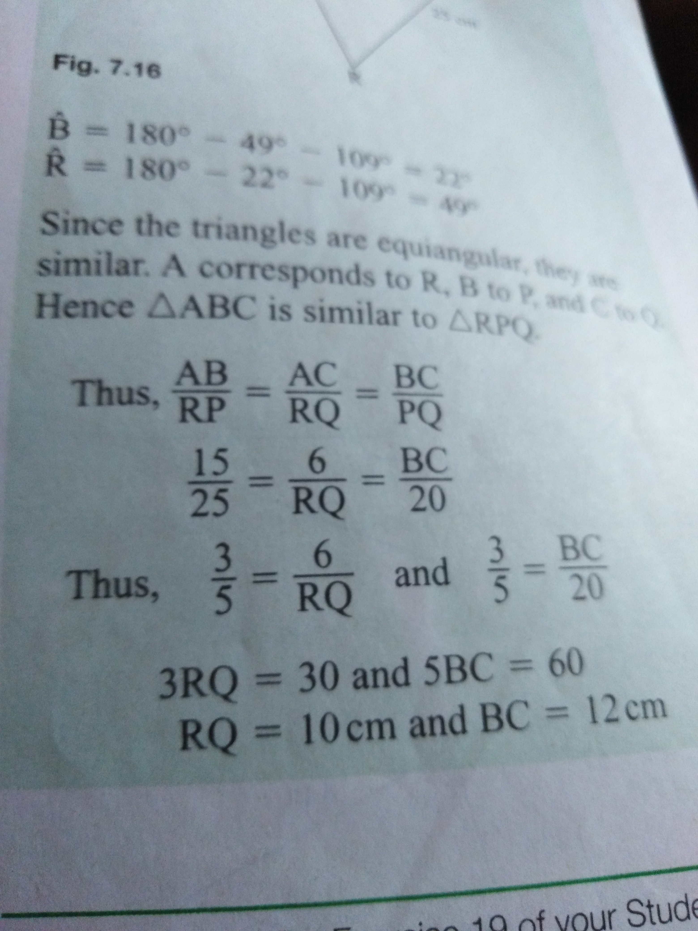
For comments and observations WhatsApp 08021443714.

DIAMOND ICE.

