ALL SAINTS’ SECONDARY SCHOOL, OYIGBO
SS 2 CHEMISTRY
LECTURE 6
TOPIC: FARADAY’S LAW OF ELECTROLYSIS
First Law of Faraday
Faraday’s first law states that the mass of a substance deposited or discharged on an electrode is directly proportional to the quantity of electricity that is passing through the electrolyte.
Let ‘m’ be the mass of the substance that deposited on the electrode, ‘Q’ is the quantity of electricity passing through the electrolyte.
m $∝$ Q
m = EQ
$∴$ E =$\frac{m}{Q}$ --------------------------------- (i)
Where E is the constant of proportionality known as the Electrochemical Equivalence. It is measured in gram per coulomb (g/C).
Recall that: Q = It
Where ‘I’ represent the current in Ampere and ‘t’ represent the time taken for the current to flow.
Substitute for Q in (i) we have
The quantity of electricity required to liberate one mole of electrons is approximately 96500C. This quantity of electricity is called FARADAY and it is denoted by ‘F’.
That is one Faraday (96500C) is required to liberate one mole of electricity.

E = $\frac{m}{It}$ ---------------------------------- (ii)

Second Law of Faraday
Faraday’s second law states that when the same quantity of electricity passes through different electrolyte connected in series, the amount of various substances discharging at the electrodes are inversely proportional to the number of charges on the ions of the substance.
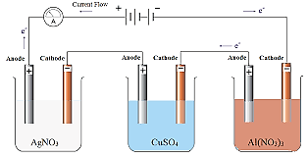
To explain this law of Faraday, consider the above diagram; the first electrolyte contains silver ion (Ag⁺), second electrolyte contains copper ion (Cu²⁺) while the last electrolyte contains aluminum ion (Al³⁺). Al³⁺ whose charge is +3 would deposit the least amount of metal on the cathode followed by Cu²⁺ with charge +2, while Ag⁺ with charge of +1 would deposit the largest amount of metal on the cathode.
Examples:
- Ag⁺_{(aq)} + e⁻ → Ag_{(s)}
1 F → 1 mole of Ag
965000C → 108g of Ag
- Cu²⁺_{(aq)} + 2e⁻ → Cu_{(s)}
2 F → 1 mole of Cu_{(s)}
$2×96500C$ → 63.5g of Cu
- Al³⁺_{(aq)} + 3e⁻ → Al_{(s)}
3 F → 1 mole of Al
$3×96500C$ → 27g of Al

Calculations
- What quantity of electricity is required to liberate 6.35g of Cu from copper (ii) compound?
(1 F = 96500C, Cu = 63.5)
Solution
Cu²⁺_{(aq)} + 2e⁻ → Cu_{(s)}
2 F → 1 mole of Cu_{(s)}
$2×96500C$ → 63.5g of Cu
193000C → 63.5g of Cu
If 63.5g of Cu was deposited by 193000C of electricity,
$∴$ 6.35g of Cu would be deposited by $\frac{6.35 ×193000}{63.5}=19300C$ of electricity

- What volume of chlorine will be liberated at s.t.p when 0.5A current of electricity passed through brine for 2hrs 10mins?
(1 F = 96500C, Vm = 22.4dm³, Cl = 35.5)

Solution
2Cl⁻_{(aq)} → Cl_{2(g)} + 2e⁻
2 F → 1 mole of Cl₂
$∴$ $2 ×96500C$ → 1 mole of Cl₂
Recall that Q =It
Q = $0.5×(2×60+10)×60C$
Q = 3900C
So, if 193000C of electricity liberates 1 mole of Cl_{2(g)},
$∴$ 3900C of electricity would liberate $\frac{3900 × 1}{193000}=0.0202$mol of Cl_{2(g)}
Recall that $n=\frac{V}{V_{m}}$
$∴$ 0.0202 = $\frac{V}{22.4}$
V = 0.0202 $×$ 22.4
V = 0.45dm³
That means at s.t.p, 0.5A of current passing through brine in 2hrs 10mins would liberate 0.45dm³ of Cl_{2(g)}.

- A certain quantity of electricity was passed through two electrolytes in series which contain molten magnesium chloride and molten aluminum chloride respectively. If 1.2g of Mg was deposited in MgCl₂ cell, what mass of Al will be deposited in the AlCl₃ cell?
(Mg = 24, Al = 27)
Solution
Mg²⁺_{(l)} + 2e⁻ → Mg_{(s)}
2 F → 24g of Mg
$2 ×96500C$ → 24g of Mg
If 24g of Mg was deposited by 193000C of electricity,
$∴$ 1.2g of Mg would be deposited by $\frac{193000 × 1.2}{24}=9650C$
That is, 9650C of electricity is what passed through the electrolytes in series.
Now for Al³⁺:

Al³⁺_{(l)} +3e⁻ → Al_{(s)}
$3 ×96500C$ → 27g of Al
289500C → 27g of Al
If 289500C of electricity deposits 27g of Al,
$∴$ 9650C of electricity would deposit$\frac{9650 × 27}{289500}=0.9$g of Al

- In the electrolysis of dilute tetraoxosulphate (vi) acid, calculate the volume of oxygen that liberated if 1930 Coulomb of electricity is passed through the solution.
(1 F = 96500C, Vm = 22.4dm³)
Solution
4OH⁻_{(aq)} → 2H₂O_{(l)} + O_{2(g)} + 4e⁻
4F → 1 mol of O_{2(g)}
4 $×$ 96500C → 1 mol of O_{2(g)}
If 386000C of electricity liberates 1 mole of O₂
$∴$ 1930C of electricity will liberate $\frac{1930 × 1}{386000}=0.005mol$ of O₂
$$n=\frac{V}{V_{m}}$$
$$0.005=\frac{V}{22.4}$$
V = 0.005 $×$ 22.4
V = 0.112dm³

USES OF ELECTROLYSIS
- Extraction of metals and purification of metals: Highly electropositive metals like Na, K, Mg, Ca, Al and Z are extracted from their ores by electrolysis. The less electropositive metals like Cu, Hg, Ag and Au tend to occur in the uncombined form in ores.
These ores are usually contaminated with these ores are usually contaminated with these ores are with impurities such as sand, limestone and iron compounds.
- Electroplating: Electroplating is a method of coating the surface f one metal with another metal using Cu, Ag, Cr, Ni or Au, by means of electrolysis for decoration or protection against corrosion. The materials which are usually plated include table wares, cutleries, jewelries and iron or steel objects.
The arrangement of the electrolytic cell is essentially the same as that used in the extraction of metals. The cathode is the metallic object which is to be coated or plated, the anode, a strip of the plating metal and the electrolyte, salt of the plating metal. Thus, in silver plating a spoon:
- The cathode is the spoon
- The anode is a silver rod
- The electrolyte is a solution of silver salt usually silver trioxonitrate (v) solution
As the current is passed through the cell, the plating metal dissociates at the anode and the ions produced migrate to the cathode, were they are discharged and deposited as a layer on the object.
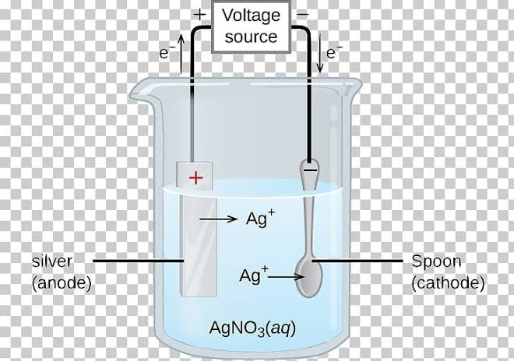
- Preparation of some important substances: the electrolysis of brine yield chlorine and hydrogen at the electrodes, and concentrated solution of sodium hydroxide.

